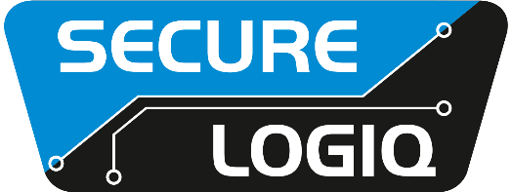

January 2022 For Immediate Release

Secure Logiq opens Middle East office

Dubai, UAE… Secure Logiq has created a direct presence in the Middle East with the official opening of a new local office. Based in Dubai, the new office will provide Secure Logiq’s local customers and partners with a direct line of contact to local sales and design specialists in their own time zone.
“The Middle East is a very important market for us and we know that to serve the region to our best ability we needed to have a local office,” said Secure Logiq’s Robin Hughes. “We were determined that we were going to do this properly, so rather than just a sales person for the region, this is a full service office. This means that our clients and partners will have easy access to local resources for design and sales, fully supported by our team at HQ in the UK.”
The new office is initially staffed by a Regional Director who will be responsible for the day-to-day operations in the region as well as a new Business Development Manager. The dedicated Middle East team brings a wealth of experience in the region’s security technology market and will grow further to better serve this important and diverse market.
Throughout 2022 Secure Logiq will continue to expand its Middle East team, with at least one new BDM, a pre-sales engineer, and an office administrator, with more positions coming as the manufacturer grows.
“We have always had global aspirations for Secure Logiq and this new office takes us another step closer to achieving that,” concluded Hughes. “I am sure this will be highly successful for us and the office will continue to expand over the coming years.”
Meet with the new Secure Logiq Middle East team at Intersec 2022 on stand S1-E46

For further information visit: www.securelogiq.com
####

Press Contact:
James Ling, The Inside Story
Tel: +44(0)1892 525141
Email: james@gettheinsidestory.com

About Secure Logiq:
Since 2011 Secure Logiq have been developing the missing piece of the HD surveillance jigsaw, servers specifically designed for HD surveillance. A new concept in the surveillance industry, our team of technical experts have over 150 years of both IP CCTV and server experience and boasts respected thought leaders from both the HD Surveillance and IT hardware industries.
In a short space of time Secure Logiq have become the world's leading independent manufacturer of servers, workstations and client machines optimised for HD Surveillance and Video Analytics applications.
Secure Logiq's company ethos is based on four core principles - to provide the Fastest Performance, the Biggest Storage, the Most Resilience and the Best Value in HD video processing, viewing and storage technology.

